**CS236781 – Deep Learning on Computational Accelerators**

Final Project

(Winter 2019-2020)

**DDSP**

Yakir Helets and Gal Fleissig

**Abstract**

**הבחירה שלנו:**

1. חשבנו להשתמש בספריה מהמאמר ולהרחיב אותה כך שהיא תכיל כלי נגינה נוספים, כלומר אנו רוצים להזין למודל דאטה סטים חדשים שניצור בעצמנו מתוך קטעי אודיו לשימוש חופשי המצויים ברשת, של כלי נגינה א׳, ולממש את ההרחבה שלנו כך שהמודל ימיר את הנגינה לכלי נגינה ב׳.

**להוסיף התייחסות ולינק למחברת שיקיר כותב**

**Intro**

The paper relevant to out project is [*DDSP: Differentiable Digital Signal Processing*](https://arxiv.org/abs/2001.04643), by Jesse Engel, Lamtharn Hantrakul, Chenjie Gu, & Adam Roberts of the Brain Team at Google Research, published as a conference paper at ICLR 2020.

The domain of this paper is the *Digital Signal Processing* (DSP, without the first “D”), which is a domain that is integral to modern society in many aspects such as telecommunications, transportation, audio and medical technologies. This paper brings a new approach to the table, by combining deep learning techniques, and by that improves upon existing approaches.

There are three existing approaches prior to this paper, all of which are part of the family of audio that belongs to generative models. The first generates samples in the domain of time. The second generates samples in the domain of frequency. These two approaches can express any signal, but they are inefficient because they do not take advantage of existing knowledge on sound properties. The third approach which is vocoders or synthesizers does utilize existing knowledge on sound properties, however since it has limited expressivity and it is difficult to adapt it to modern auto differentiation machine learning methods – it has been less actively researched.

The contribution of the relevant paper is by introducing a new method called *Differentiable Digital Signal Processing* (or DDSP), along with its library. The new method uses a neural network to convert input into complex DSP controls that can produce more realistic signals. This method unlike the previous methods enables for direct integration of classic signal processing elements using deep learning methods. In other words, the DDSP units are differentiable (hence the name) which allows to train the neural network to learn a new dataset using the known process of backpropagation, and by that to achieve better results than existing approaches.

The paper focuses on audio synthesis and by that achieves high quality audio generation without the need for large models or adversarial losses. Additionally, it shows that combining different modules allows for manipulation of each of the model components individually. And in general, the DDSP approach towards the domain is interpretable and modular while still using the benefits of deep learning techniques.

Some of the interesting applications of this approach include independent control of pitch and loudness, transfer of the acoustics of one room to another and transfer of audio signals from one domain to another (e.g. singing to a violin).

**Methods**

We are going to base our work on the DDSP paper that was presented in the previous section. The paper introduced to the readers a few applications. These included what is called by the authors *‘timbre transfer between disparate sources’*. Simply put, they refer by that to creating a neural network that trains on samples of audio (with only one instrument playing) and then performs transfer of one audio source to the other (the inference). For instance, after training the network on violin data samples, they provide a transfer from singing audio segment to a violin audio segment.

Considering the task and domain at hand, we came up with a few ideas for modifications to the original applications presented. In our work we would like to explore the approach of extending the range of audio sources of the timbre transfer, and by that create a larger variety of timbre transfer possibilities, one of the main applications of the paper.

While the theoretical aspect of our work has mostly remained the same as the one described in the paper, the empirical one is different. As stated, we are going to extend the variety of timbre transfer applications to include new and exciting instruments that may have not been tested before, and by that add to the empirical experience of the domain and the authors of the paper.

We would like to explore not simply other instruments with this application, but more specifically instruments that one can normally find in other styles of music, that usually differ from classical violin music. Therefore, we plan to introduce the timbre transfer of a guitar audio file into singing audio file, and by that experiment show that the neural network at hand can cope with instruments that are not only from the classical music style, but also from other styles.

The data that we are using for the first two experiments is taken from [AudioSet](https://research.google.com/audioset/), a Google resource for audio segments. We took a 4-minute and a 32:47-minutes long audio sample of an acoustic guitar (with no background audio), after trimming quiet parts from the beginning and the end. The data used for the third experiment is also taken from AudioSet, and it is a ….. minute long audio sample of cello (again, with no background audio).

**Implementation and Experiments**

We are using a model of a neural network in the form of an autoencoder. The network is comprised of a deterministic autoencoder, and an RNN fully connected decoder with 4,801,150 parameters. It also includes a processor group layer with 48,000 parameters, which makes a total of 4,849,150 parameters, all trainable.

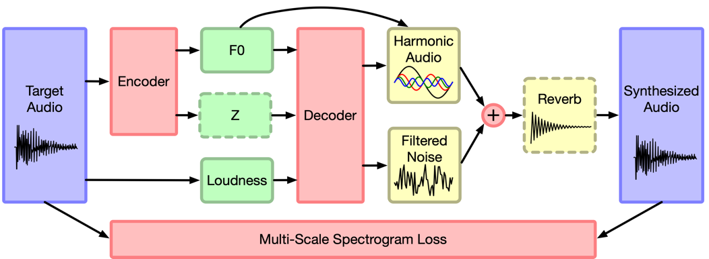

**The autoencoder network**

During the training, we are measuring the spectral loss, which was introduced in the [STFT spectral loss for training a neural speech waveform model](https://arxiv.org/abs/1810.11945) paper, by Shinji Takaki, Toru Nakashika, Xin Wang and Junichi Yamagishi in 2018. This paper proposed this new form of loss using short-time Fourier transform (STFT) spectra for the aim of training a high-performance neural speech waveform model that predicts raw continuous speech waveform samples directly.

We will note here that the recommendation of the repository creators is to reach a loss of a value between 4.5 and 5. They advise to not have the loss go below this threshold as the network might experience overfitting.

We performed a few experiments. In the beginning we wanted to explore the option of timbre transfer of audio segments from singing to guitar. We performed two experiments in this direction, that were similar in their characteristics. One with a relatively short dataset of 4 minutes of acoustic guitar, and the other was with a long dataset of 32 minutes.

Based on the results of these experiments (details in the Results section of this report) we decided to perform a third experiment, where the goal is a timbre transfer from singing to double bass. We expected to get better results with this instrument because double bass and violin are closely related in their characteristics, and the results on a violin are very good in the paper.

**INSERT HERE ORIGINAL ‘SOMEWHERE OVER THE RAINBOW’**

There are two main evaluation metrics we used in order to test the performance of the autoencoder. We used these because they give us a good sense of understanding as to how well our model is performing.

The first one as learnt in class and is widely known in the area of VAE is to compare the decoded information to the original information (before the encoding). This gives us an accurate estimation as to how well the frequencies were restored in the process. This information for our experiments can be found in the dark graphs under the ‘Results’ section.

The second one is less accurate but can give an immediate sense to the listener as to how well the model has performed, and that is to listen to the output. In this way we can compare the result to the desired one and to other results of the same neural network. We will note however that because this method is less accurate, we will only rely on this form of evaluation as a helper, and not as the main metric.

In terms of hyper parameters, we are looking at three different ones in the inference step which one can manually tune:

* **f0_octave_shift** – Shifts the fundamental frequency to a more natural register
* **f0_confidence_threshold** – Silences audio below a threshold
* **loudness_db_shift** – Adjusts the overall loudness level

**Results**

For the first two experiments (guitar), we noticed that they did not go as expected. After the training step, the inference step produced results that are more similar to a violin, even after tuning the hyperparameters in multiple ways.

Following are the results in tables:

|  |  |
| --- | --- |
|  | **Short guitar**  **(experiment 1)** |
| **Total training time** | ~12 hours |
| **Stopped at** | ~18,000 steps |

|  |  |  |  |
| --- | --- | --- | --- |
|  | **Long guitar**  **(experiment 2)** | **Reconstruction diagram** | **Loss diagram** |
| **Total training time** | ~42 hours |  |  |
| **45,000 steps** | Loss = 5.5546 |  |  |
| **70,500 steps** | Loss = 5.371 |  |  |
| **91,800 steps** | Loss = 5.319 |  |  |
| **Stopped at** | ~91,800 steps |  |  |

Our assumption is that the network model works best for instruments with smoother transition between notes, such as instruments form the string family. Guitar, as opposed to those instruments, have a much less smooth transition like so.

And so as stated above, we decided to perform a third experiment, which did go well when we evaluated the results using the metrics above.

|  |  |  |  |
| --- | --- | --- | --- |
|  | **Double Bass**  **(experiment 3)** | **Reconstruction diagram** | **Loss diagram** |
| **Total training time** | ~16 hours |  |  |
| **18,000 steps** | Loss = 5.70 |  |  |
| **34,800 steps** | Loss = 5.57 |  |  |

General notes (for all experiments):

We notice that the network is indeed learning, as we can see in the loss diagrams that the loss is growing smaller with time. However, as mentioned, we would not like it to be too small to avoid overfitting.

Here is the place to note that in some of the experiments the total training time was forced by Google Colab since it has a time limit, and in some of the experiments we did not have to reach this limit because the results were satisfactory. In any case, the results were stabilized before the training has stopped, either by us or by the platform, as can be seen in the loss diagrams.

**כל הגרפים שיקיר שלח מתייחסים ל-long guitar**

**לנסות להוסיף קטעי אודיו**

**הרצה של דאבל באס על ההיפר פרמטרים על הדיפולטיבי וזה היה טוב. נשמע יותר טוב כשה-f0 octave shift היה על מינוס אחד (היה יותר תואם למקור).**

**אחרי 45,000 צעדים, לוס של 5.5546.**

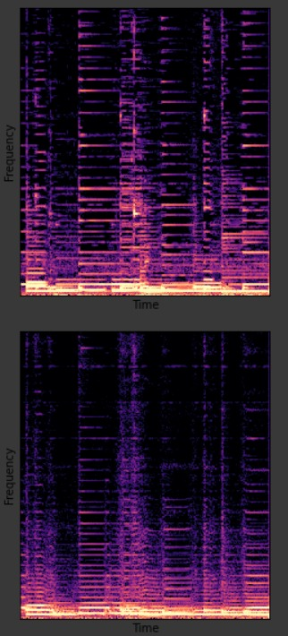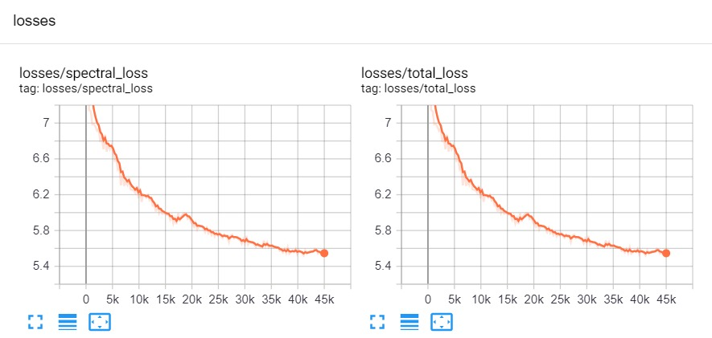

**אחרי 70,500 צעדים, לוס של 5.371 (יש קבצי אודיו)**

**מספר של 91,800 צעדים – גרפים: (יש קבצי אודיו)**

**ה-double bass, 18,000 צעדים**

**ה-double bass, 34,800 צעדים**

**קובץ dbass 34800 orig בהורדות**

**קובץ dbass 34800 resynthesis בהורדות**

**לשאול את יקיר מה זה:**

